# F. Y. B. Tech 2021-22

**Subject:** Basics of Electrical and Electronics Engineering **Trimester: II**

**Name: Shreerang Mhatre Division: 11**

**Roll No: 111056 Batch: K3**

# Experiment No: 9

**Name of the Experiment: Finding Efficiency and regulation of single phase transformer by using Indirect Loading Method.**

**Performed on: 19/02/2022**

**Submitted on: 21/02/2022**

# Aim: To determine the efficiency and regulation of the transformer by indirect loading (O.C. and S.C. test) of single-phase transformer.

**Objective**

* To understand the indirect loading test of transformer
* To calculate percentage efficiency
* To calculate percentage regulation

**Components and Equipment required**

|  |  |  |
| --- | --- | --- |
| **Components** | **Specifications** |  |
| Single phase transformer | 230/115 V, 50 Hz, 1 kVA |
| A.C. Voltmeter | 0-230 V, 0-150 V |
| A.C. Ammeter | 0-5 A, 0-10 A |
| Wattmeter | 0-750/1500/3000/6000 W |  |

**Theory**

A transformer is used to transfer electrical energy from one circuit to another at same

frequency but at different voltages, depending upon the ratio of the number of turns of primary and secondary winding of the device. Even if the primary voltage applied to the transformer is kept constant, it is observed that secondary terminal voltage varies as the load current is increased. This is because of the voltage drops across resistances and leakage reactance of winding.

Voltage regulation of a transformer is defined as the change in the secondary terminal voltage from NO LOAD to FULL LOAD expressed as the fraction of the NO LOAD voltage, with primary voltage kept constant.

If *E*2 =secondary terminal voltage on NO LOAD, volt

*V*2 = secondary terminal voltage on LOAD of amp

= current flowing through secondary winding Then, the regulation of Single phase transformer is

(1)

Efficiency is defined as the ratio of the power output to power input. Its value is always less than one due to the various losses taking place in the transformer. The losses can be divided into two categories:

1. **Iron or core loss:** This includes the hysteresis and eddy current loss taking place in the iron core. For a fixed frequency and fixed primary voltage, the iron loss remains constant, irrespective of any change in the load current.
2. **Copper loss:** The power loss taking place in the windings of a transformer due to their own resistance is called as copper loss (). This loss varies according to the load current .

It is possible to predict the performance of a transformer at various loadings by knowing all the equivalent circuit parameters. These circuit parameters are supplied in terms Open Circuit (OC) and Short Circuit (SC) test data of a transformer. Without actually loading the transformer, these two assessed tests give the test results which are used to determine the equivalent circuit parameters. By these parameters, we can easily predetermine the efficiency and regulation of the transformer at any power factor condition as well as at any load condition. This method of finding the parameters of a transformer is called as an indirect loading method.

**Open circuit test (No load test):**

The purpose of the open-circuit test is to determine the no-load current and losses of the transformer because of which their no-load parameter is determined. This test is performed on the primary winding of the transformer. The wattmeter, ammeter, and the voltage are connected to their

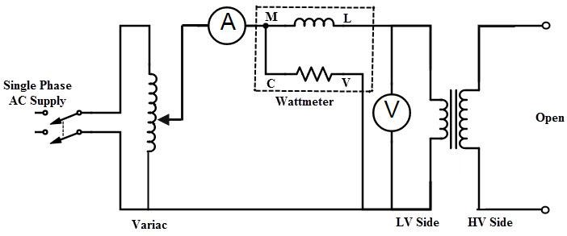primary winding. The nominal rated voltage is supplied to their primary winding with the help of the ac source. The secondary winding of the transformer is kept open and the voltmeter is connected to their terminal. This voltmeter measures the secondary induced voltage. As the secondary of the transformer is open the no-load current flows through the primary winding. The value of no-load current is very small as compared to the full rated current. The copper loss occurs only on the primary winding of the transformer because the secondary winding is open. The reading of the wattmeter only represents the core and iron losses. The core loss of the transformer is same for all types of loads. The OC test arrangement of a transformer is shown in below figure.

**Fig. 1: Circuit diagram for open circuit (no load) test on transformer Short circuit test :**

The short circuit test is performed for determining the below mentioned parameters of the transformer.

1. It determines the copper loss occurs on the full load. The copper loss is used for finding the efficiency of the transformer.
2. The equivalent resistance, impedance, and leakage reactance are known by the short circuit test.

The short circuit test is performed on the secondary or high voltage winding of the transformer. The measuring instrument like wattmeter, voltmeter, and ammeter are connected to the high voltage winding of the transformer. Their secondary winding is short circuited by the help of thick strip or ammeter which is connected to their terminal. The low voltage source is connected across the secondary winding because of which the full load current flows from both the secondary and the primary winding of the transformer. The full load current is measured by the ammeter connected across their secondary winding.

The low voltage source is applied across the secondary winding which is approximately 5 to 10% of the normal rated voltage. The flux is set up in the core of the transformer. The magnitude of the flux is small as compared to the normal flux. The iron loss of the transformer depends on the flux. It is

less occur in the short circuit test because of the low value of flux. The reading of the wattmeter only determines the copper loss occur on their windings. The voltmeter measures the voltage applied to their high voltage winding. The secondary current induces in the transformer because of the applied voltage.

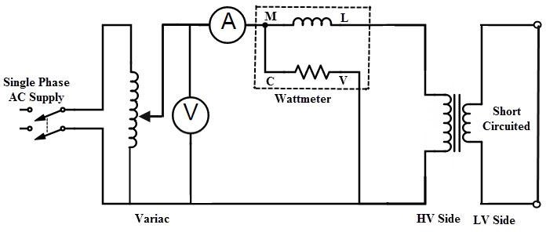

**Fig. 2: Circuit diagram for short circuit test on transformer**

**Procedure:**

1. Make the proper connection by clicking the node as instructed below. If the wire is misplaced, click the node number to detach the nodes wire.
2. Then click autotransformer to get the change in all meter.
3. Then click add to table button to get the reading of over open circuit transformer.
4. Then we have done open circuit transformer test. Then click short button for short circuit

transformer test.

1. Make the proper connection by clicking the node as instructed below. If the wire is misplaced, click

the node number to detach the nodes wire.

6. Then click check button to check connection is correct or not.

7. Then click add to table button to get the reading of over short circuit transformer.

8. Then we have done short circuit transformer test. Then click submit button for get result.

9. Then we have the result in diagram form. We also print the result by click on print bu

**Observation Table:**

**Open circuit test (No load test):**

|  |  |  |
| --- | --- | --- |
| **Poc (Watt)** | **Ioc (Amp)** | **Voc (Volt)** |
| **50** | **0.9** | **230** |

**Circuit:**

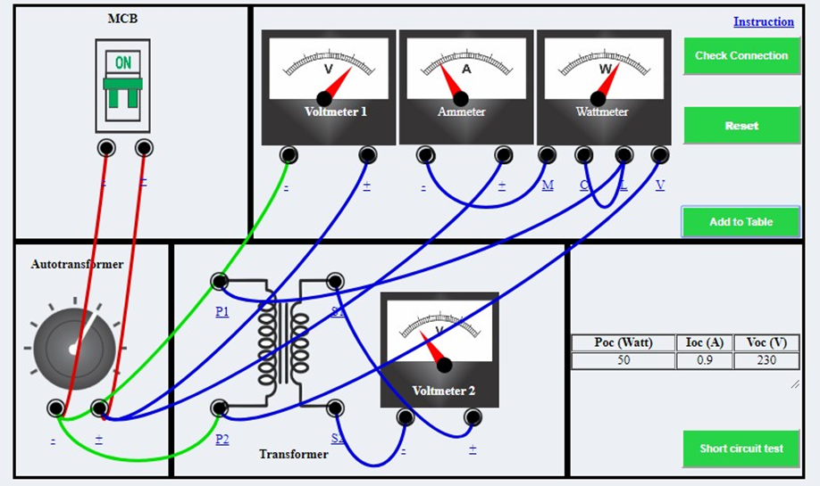

**Short circuit test:**

|  |  |  |
| --- | --- | --- |
| **Psc (Watt)** | **Isc (Amp)** | **Vsc (Volt)** |
| **37.5** | **4.5** | **11** |

**Circuit:**

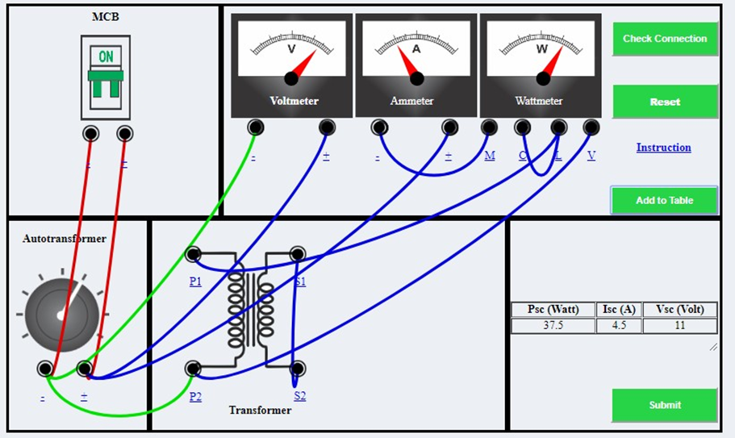

**Determination of Transformer equivalent circuit from Open Circuit and Short Circuit Test.**

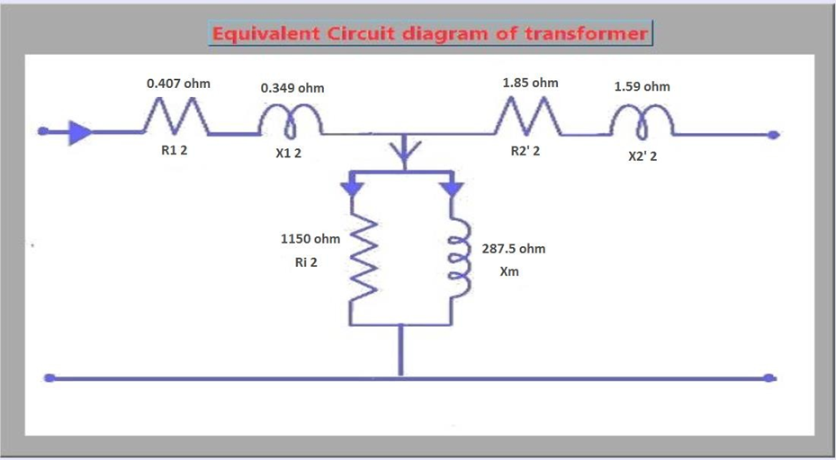

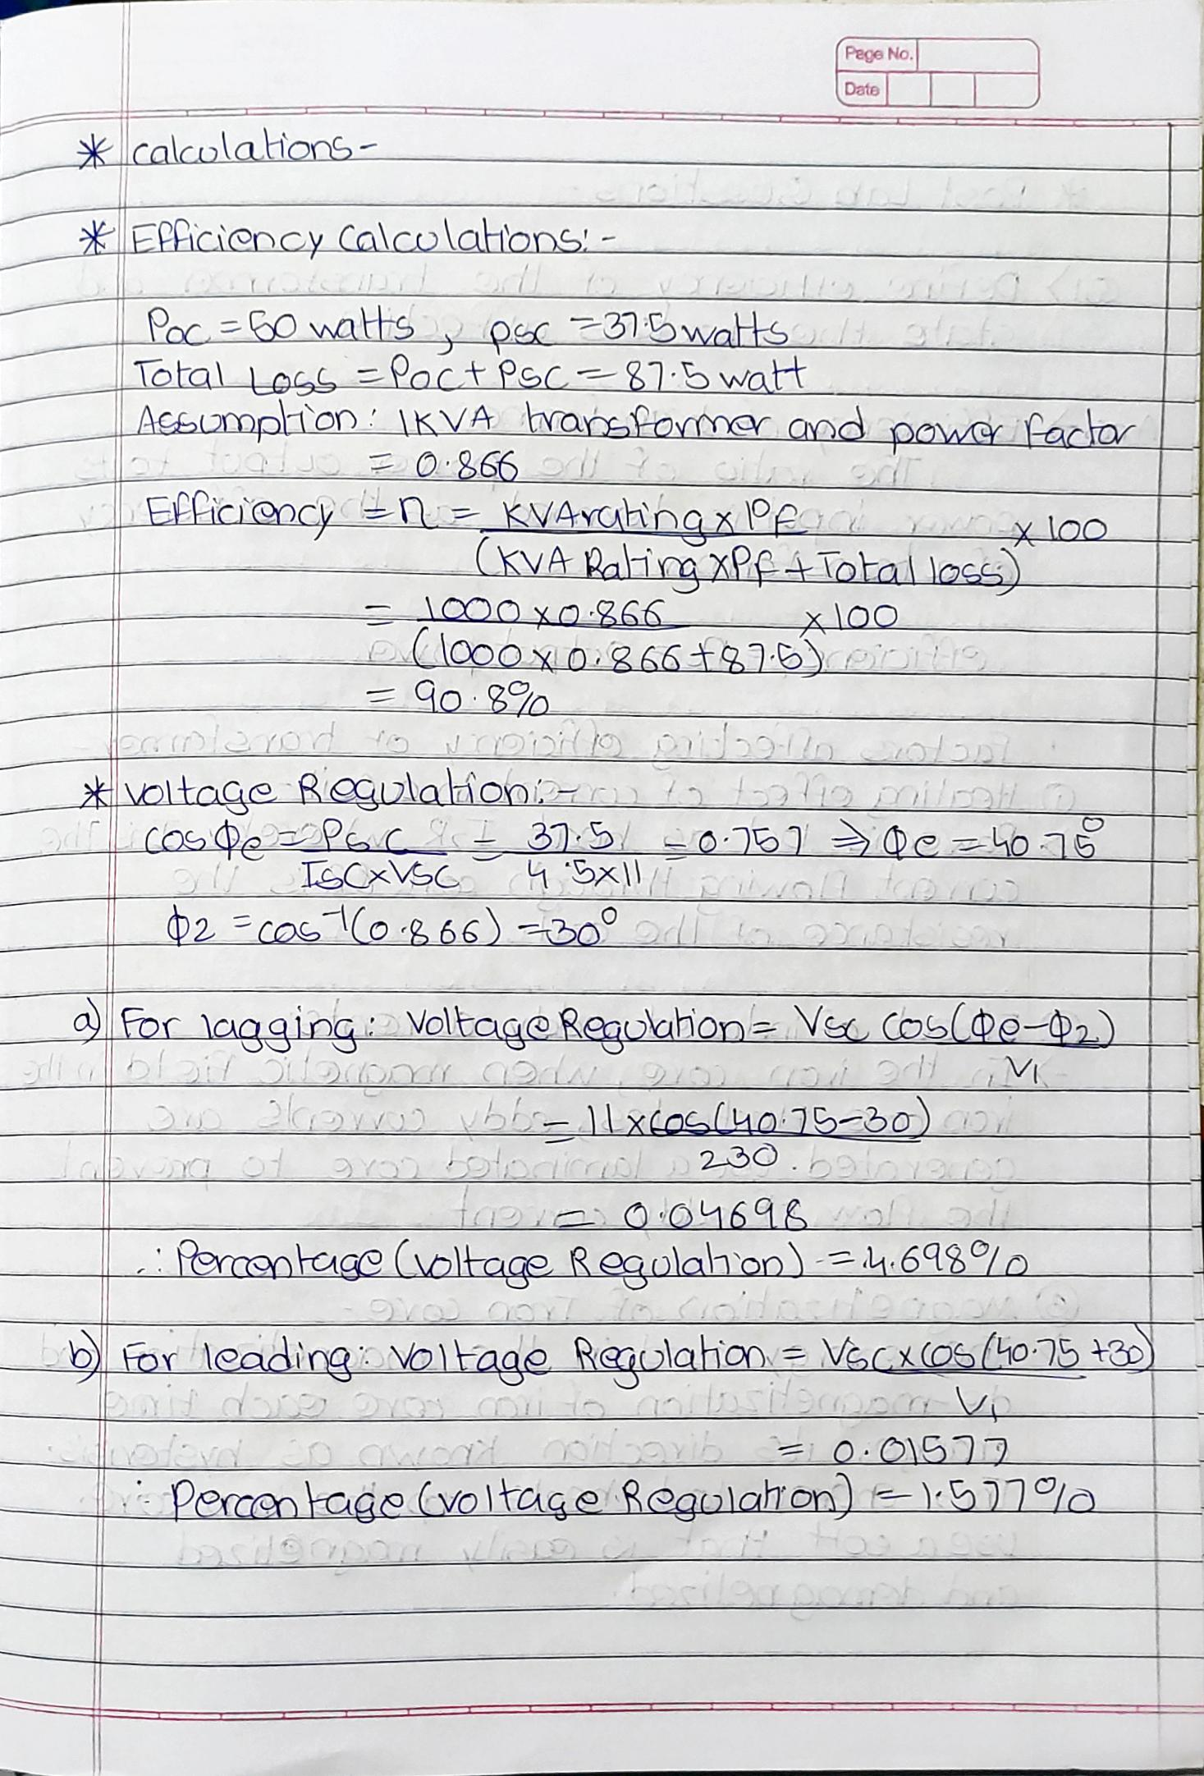

**Calculations:**

**Important Note:**

* Efficiency is calculated from open circuit and short circuit test.
* Regulation is calculated from short circuit test.

1. **Efficiency:**

**Where,**

S = full load kVA rating = 1 kVA here = 1000 Watt.

P.F. = load power factor = 0.866 lagging (Assume)

*P*oc = input power in watts ***on the open-circuit test***

= core loss

*P*sc = input power in watts ***on the short-circuit test*** with full-load currents

= total *I*2*R* loss on full load

Then, Total loss on full load = *P*oc + *P*sc

1. **Regulation:**

Where,

Cos Øe = power factor on short-circuit test

Cos Ø2 = Load power factor = 0.866 lagging (Assume) V1 = Primary applied voltage = 230 V

Isc = Primary current

(**Note:** The positive sign is used for lagging power factor and negative sign is used for leading power factor.)

**Result:**

|  |  |  |  |
| --- | --- | --- | --- |
| **% Loading** | **Load power factor** | **% Regulation** | **% Efficiency** |
| **Full load** | 0.866 | 1.576 | 90.82 |

**Conclusion:**

Hence, we have determined the efficiency and regulation of the transformer

by indirect loading (open circuit and short circuit)

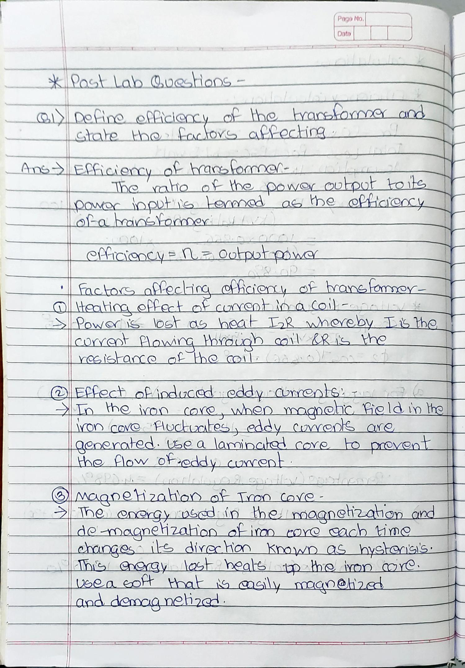

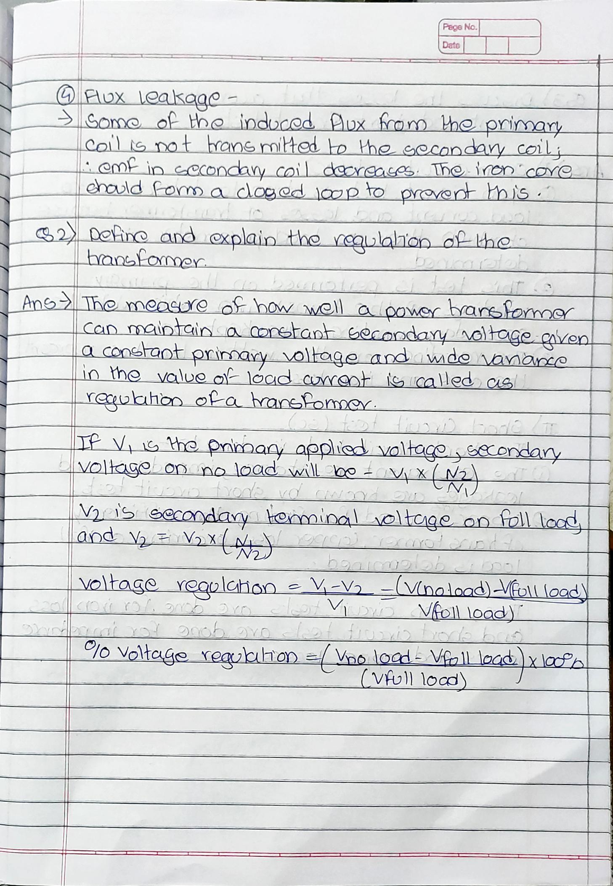

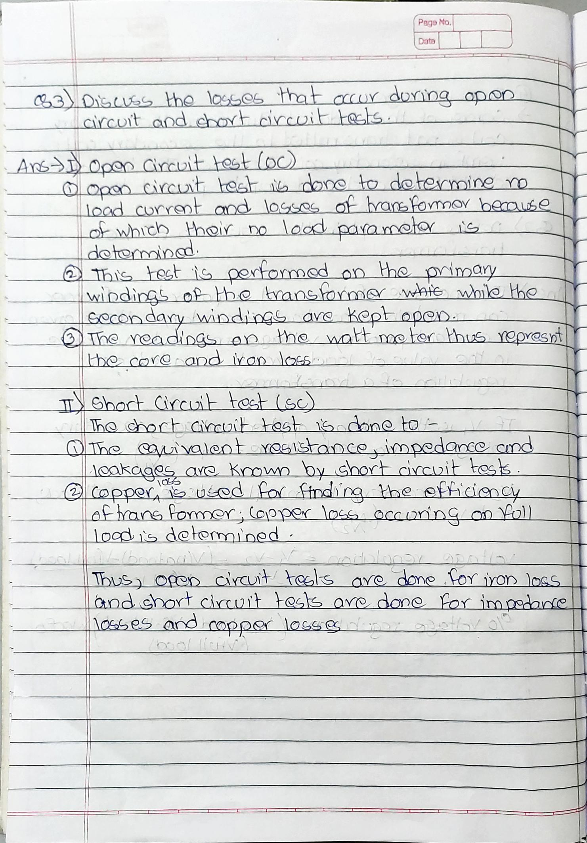

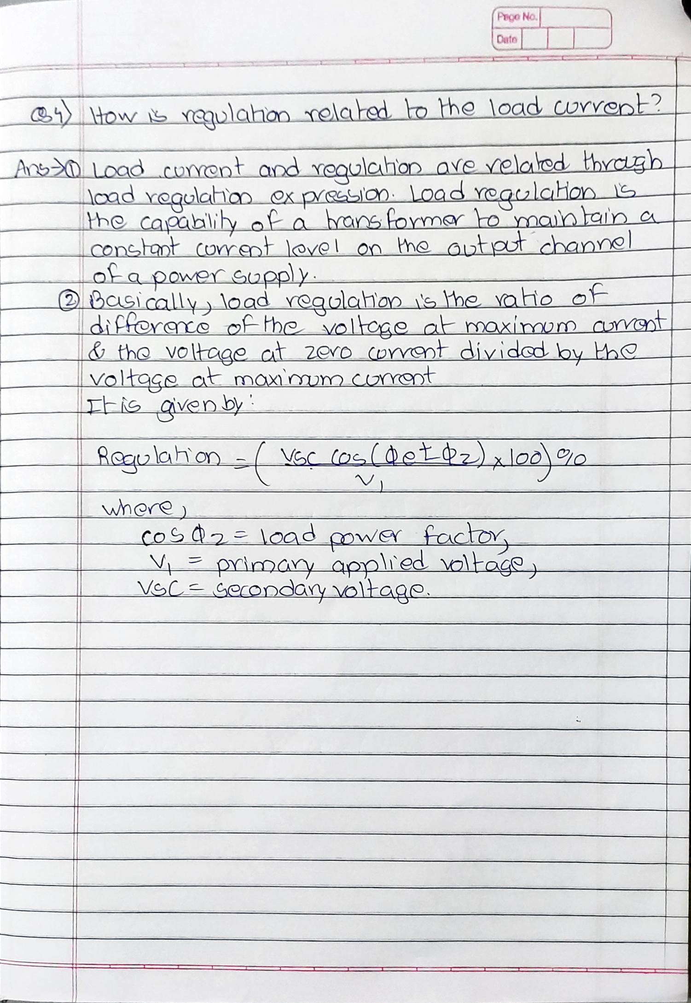

**Post-Lab Questions:**

1. Define efficiency of the transformer and state the factors affecting.
2. Define and explain the regulation of the transformer.
3. Discuss the losses that occur during open circuit and short circuit tests.
4. How is regulation related to the load current?

**Note: Students are instructed to do all necessary calculations and answer the questions on separate sheets and attach them.**